Mock API Services

🌟 Definition
# Source: AI Source: Provided by: [Data Path: Persons Table -> ID Column: 1, Name_En Column: Motasem Essam] -> From: [ChatGPT] on [5/31/2026]
Mock API Services are systems that provide fake (simulated) APIs that behave like real APIs but do not use real backend logic or real databases.
They return predefined or generated data to simulate real server responses.

🎯 Purpose
# Source: AI Source: Provided by: [Data Path: Persons Table -> ID Column: 1, Name_En Column: Motasem Essam] -> From: [ChatGPT] on [5/31/2026]
- To test applications without a real backend
- To help frontend developers work independently
- To simulate API behavior during development
- To speed up software development
- To prototype applications quickly
- To test edge cases and error handling

🧩 How Mock APIs Work
# Source: AI Source: Provided by: [Data Path: Persons Table -> ID Column: 1, Name_En Column: Motasem Essam] -> From: [ChatGPT] on [5/31/2026]
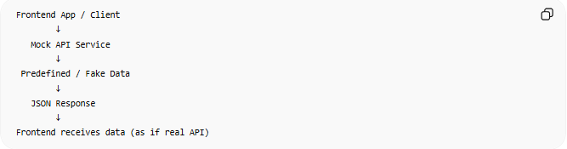
Frontend App / Client
↓
Mock API Service
↓
Predefined / Fake Data
↓
JSON Response
↓
Frontend receives data (as if real API)

📚 Main Features

1. Fake Data Responses
# Source: AI Source: Provided by: [Data Path: Persons Table -> ID Column: 1, Name_En Column: Motasem Essam] -> From: [ChatGPT] on [5/31/2026]
Returns structured data like real APIs.
Example:
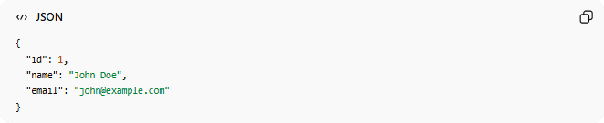
{
"id": 1,
"name": "John Doe",
"email": "john@example.com"
}

2. No Real Database
# Source: AI Source: Provided by: [Data Path: Persons Table -> ID Column: 1, Name_En Column: Motasem Essam] -> From: [ChatGPT] on [5/31/2026]
- Data is not stored permanently
- Responses are simulated

3. Same API Structure as Real APIs
# Source: AI Source: Provided by: [Data Path: Persons Table -> ID Column: 1, Name_En Column: Motasem Essam] -> From: [ChatGPT] on [5/31/2026]
Supports:
- GET
- POST
- PUT
- DELETE

4. Fast and Lightweight
# Source: AI Source: Provided by: [Data Path: Persons Table -> ID Column: 1, Name_En Column: Motasem Essam] -> From: [ChatGPT] on [5/31/2026]
- No backend processing delays
- Instant responses

📚 Examples of Mock API Services

1. JSONPlaceholder
# Source: AI Source: Provided by: [Data Path: Persons Table -> ID Column: 1, Name_En Column: Motasem Essam] -> From: [ChatGPT] on [5/31/2026]
JSONPlaceholder
Fake REST API for testing and learning.

2. Mockoon
# Source: AI Source: Provided by: [Data Path: Persons Table -> ID Column: 1, Name_En Column: Motasem Essam] -> From: [ChatGPT] on [5/31/2026]
Mockoon
Desktop tool to create custom mock APIs.

3. MockAPI
# Source: AI Source: Provided by: [Data Path: Persons Table -> ID Column: 1, Name_En Column: Motasem Essam] -> From: [ChatGPT] on [5/31/2026]
MockAPI
Lets you build fake REST APIs with database-like structure.

4. Postman Mock Servers
# Source: AI Source: Provided by: [Data Path: Persons Table -> ID Column: 1, Name_En Column: Motasem Essam] -> From: [ChatGPT] on [5/31/2026]
Postman
Allows you to create mock APIs inside Postman.

🧠 Why Mock APIs are important
# Source: AI Source: Provided by: [Data Path: Persons Table -> ID Column: 1, Name_En Column: Motasem Essam] -> From: [ChatGPT] on [5/31/2026]
For Frontend Developers
- Build UI without waiting for backend
For Backend Developers
- Test APIs before real implementation
For QA Testing
- Simulate errors and edge cases
For Learning
- Practice API calls safely

⚖️ Mock API vs Real API
# Source: AI Source: Provided by: [Data Path: Persons Table -> ID Column: 1, Name_En Column: Motasem Essam] -> From: [ChatGPT] on [5/31/2026]
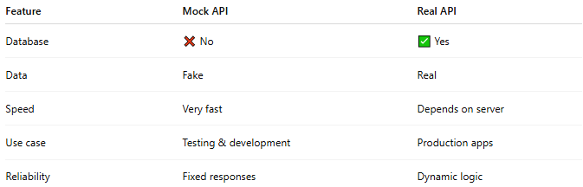
Feature | Mock API | Real API
Database | ❌ No | ✅ Yes
Data | Fake | Real
Speed | Very fast | Depends on server
Use case | Testing & development | Production apps
Reliability | Fixed responses | Dynamic logic

🧠 Simple Analogy
# Source: AI Source: Provided by: [Data Path: Persons Table -> ID Column: 1, Name_En Column: Motasem Essam] -> From: [ChatGPT] on [5/31/2026]
Mock APIs are like:
- 🎭 Actors in a rehearsal
- They behave like real characters
- But it’s not the real performance yet
So developers can practice before the real system is ready.

🧭 Summary
# Source: AI Source: Provided by: [Data Path: Persons Table -> ID Column: 1, Name_En Column: Motasem Essam] -> From: [ChatGPT] on [5/31/2026]
Mock API Services are tools that simulate real APIs by returning fake but structured data, allowing developers to test, build, and design applications without needing a real backend system.

